Adapting The Throttle & Steering Controls of a Motorized Toy Car to a Joystick Interface

Francisco Cuen, Michael Riley, Jaclyn Pellegrini, Caleb Kasayka
The Snow Munchers & GoBabyGo
Colorado Mesa University

Table of Contents
- Executive Summary.....................................................................................1
- Problem Definition....................................................................................2-3
  - PROBLEM SCOPE
  - TECHNICAL REVIEW
    - BACKGROUND
    - EXISTING SOLUTIONS
  - DESIGN REQUIREMENTS & CRITERIA

- Design Description....................................................................................3-6
  - OVERVIEW
  - DETAILED DESCRIPTION
    - JOYSTICK
    - JOYSTICK MOUNT
    - PRINTED CIRCUIT BOARD (PCB)
    - H-BRIDGE CONTROLLER
    - 555 TIMER
    - PULSE SHAPING MODULE

- Design Evaluation...................................................................................6-12
  - OVERVIEW
    - CRITERIA 1 – DIRECTIONAL CONTROL
      - PURPOSE OF EVALUATION
      - TESTING METHODS
      - RESULTS & DISCUSSIONS
    - CRITERIA 2 – STEERING CONSISTENCY
    - CRITERIA 3 – POWER LIMIT
    - CRITERIA 4 – HEAT LIMIT
    - CRITERIA 5 – SIZE REQUIREMENT

- Team Performance.....................................................................................13
- Conclusions & Recommendations............................................................13
  - RECOMMENDATIONS
  - RECOMMENDED NEXT STEPS
- References...................................................................................................14
- Appendices............................................................................................15-18

- Executive Summary
Background
“GoBabyGo” is a non-profit organization dedicated to providing children with limited mobility the opportunity to play independently by adapting motorized toy cars. Many children with mobility challenges struggle to press the pedal and steer simultaneously, making it difficult to operate the vehicle without constant assistance. Typical “GoBabyGo” modifications reroute the pedal wiring to a button mounted on the steering wheel, simplifying acceleration and improving usability.
Project Purpose
While the standard modifications help many children, some still find it difficult to press a button and steer at the same time. This project aims to create a more intuitive control system by replacing both the pedal and steering wheel with a single joystick. The joystick must control forward and backward motion as well as left and right steering, operate safely under 12 V and 3 A, and be implemented for under $200.
Design Selected
Because the team had limited electrical engineering experience, simplicity was a major design priority. The final design used a circuit that routed power through the joystick. When the forward or backward button was pressed, the joystick sent power to an H-bridge motor controller, which drove the rear motor in the appropriate direction. Steering was controlled by a second H-bridge connected to the front motor. To prevent mechanical damage from over-rotation, the joystick sent timed pulses rather than continuous power. This was achieved using 555 timers and a pulse shaping module that generated the negative pulse required for proper 555 operation.
Results & Conclusions
After multiple iterations, the final design operated successfully and remained within budget. It reliably controlled forward/backward motion and steering, and testing showed consistent performance with minimal drift. The system was safe, intuitive, and easy for children to use. Future work should focus on simplifying the steering circuit and adapting the design for broader use across different ride-on car models to benefit more children.

- Problem Definition
  - PROBLEM SCOPE
This paper documents the redesign of a motorized toy car by adapting the controls to run via a joystick for the program “GoBabyGo!”. They are an organization at Colorado Mesa University that aims to aid in the issue of children—with limited mobility—not being able to utilize normal motorized kid cars. This idea of adapting a joystick controller is founded on the original “GoBabyGo!” adaptation of replacing the traditional “gas” pedal with a switch-powered button located on the steering wheel [1]. The issue with this different access for independent mobility is that there are children with limited mobility in the sense that they cannot maneuver the traditional steering wheel while simultaneously pressing the button to move the car. With this realization, Dr. Santos, the head of “GoBabyGo!” tasked the Snow Munchers, with the development of this joystick controller to access the “go” motion and steering all in one component. This makes the operation of the car more intuitive and user friendly for the client.

  - TECHNICAL REVIEW
    - BACKGROUND: “GoBabyGo!” is a charitable program that takes ride-on toy cars and modifies them for children with limited mobility problems. Their intent is to promote independence, exploration, and play in children who might struggle in these areas due to their limited mobility. In the past, many electric kids' cars have been modified for children with limited mobility, most commonly by removing the gas pedal and attaching a button to the steering wheel that controls the “go.” (As seen in Appendix A) [2]. This is a great modification for children with limited mobility in their lower limbs, but this does not consider the children with limited mobility in their hands and arms and is not very intuitive. The steering wheel is still a problem for them as they cannot push the button and steer the wheel at the same time, which keeps them from operating these cars at the independent level which they want to.

    - EXISTING SOLUTIONS: By no means are the Snow Munchers the first ones to create a children's car controlled by a joystick. There have been several other designs made over the years where engineers have implemented a joystick to control the movements of cars that are very similar to the Snow Munchers. An example of this is Autodesk’s “Make a Joystick-controlled Ride-on Car” (as seen in Appendix B) which controls the steering and go through a microcontroller and other complicated electronics. [3] The issue with designs like these is that they are costly and more complicated as a microcontroller needs coding and complicates the system. The Snow Munchers design avoids replacing the control unit in the car by removing the old input methods, steering wheel and gas pedal, and diverting the wires to the joystick then through a circuit which connects to H-bridge motor controllers to control the forward, backward, and steering motors. This allows us to cut out buying a new control unit or coding a microcontroller. This cuts down on complexity and cost immensely. This is reflected by the fact that past designs like the “Autodesk” model cost upwards of $300.

  - DESIGN REQUIREMENTS & CRITERIA
The project deliverable is an optimized joystick controlled system that replaces the original steering wheel and pedal interface of a child’s electric ride-on car. The system must meet the following measurable design requirements:
- Directional Control
  - Requirement: Provide forward, reverse, left, and right motion; each direction successfully actuates correct motor behavior 10/10 trials with a response rate of .5 second.
- Consistent Steering & Speed Response
  - Requirement: Vehicle follows the same path in 5 repeated trials within acceptable tolerance (e.g., ±6 inches lateral drift over 10-15ft).
- 10. 12V Maximum Power
  - Requirement: Must not exceed 12V thought out the electrical system.
- Dashboard Fit
  - Requirement: Total joystick assembly dimensions must not exceed 2.75 in (height) × 3.125 in (width). Zero interference points and no natural obstructions.
- Heat Limit
  - Requirement: Must not exceed 113° over 15 minute time intervals.

- Design Description
  - OVERVIEW
The joy-stick integrated kid car is a redesign of traditional steering and throttle controls. The functioning portion of this new joystick is implemented into the car’s original wiring circuit using a H-Bridge DC Motor Controller. For each positive or negative x and y direction, the joystick assigns all four switches to one specific direction. With each input, this will signal power for the throttle through the H-Bridge motor controller and also steering motor controls. For use on the car, it is simply mounted on the dashboard using nuts and bolts, and the corresponding 3D printed mount (eventually machined out of carbon steel). Appendix C represents a block diagram of the circuit.

  - DETAILED DESCRIPTION
    - JOYSTICK - The joystick has five wires with a gauge of 23 AWG (American Wire Gauge). These wires are connected to a circuit board via a connector. This system consists of four signal wires, each for a different switch that is also connected to the circuit board. The last wire (supply wire as seen in Appendix D) serves as a 5v-12v source wire; the input (5v-12v) will flow through this wire and in return, will output through one of the four switches (possibly two) depending on which switch is compressed or activated. Appendix D illustrates the internal switching logic of the joystick.

    - JOYSTICK MOUNT - The joystick already has two existing mounting holes, 0.278 inches in diameter, implemented into the factory design. With this, a CAD drawing was produced and integrated with these existing holes (see Appendix E). The design functions similar to a washer where it will mount on the original steering wheel location. Two bolts will run through the top (the side where the joystick extrudes), and below there will be two nuts securing the simple assembly in place. Appendix E consists of a SolidWorks drawing of the mount.

    - PRINTED CIRCUIT BOARD (PCB) - The circuit board serves as the central control interface between the joystick input and the motorized drive system of the adapted ride on car. This subsystem houses the H-bridge motor controller and 555 Timer. It provides organized electrical connections between the joystick, power supply, and DC motors. Its primary function is to safely and reliably control the direction and motion of the vehicle while meeting accessibility and safety design criteria. Refer to Appendix I to see the board.

    - H-BRIDGE CONTROLLER - When an input is received, it sends a signal to the H-bridge motor controller which recognizes the voltage as a directional input and then outputs that signal into the motor itself. This allows for safe, effective, bi-directional movement. The H-bridge has a total of 12 attachment points. two for power in, two for power to motor, two for input detection (seen as “IN” in Appendix F), two for inhibiting direction (“INH” in Appendix F, two for ISs (seen in Appendix F), a ground for the logic board (GND in Appendix F), and a 5.5V input for the logic board (“VCC” in Appendix F). This design will take advantage of all the inputs / outputs except for the SIs. Full representation of the function of an H-Bridge Controller can be found in Appendix F.

    - 555 TIMER - A 555 timer is an integrated circuit that takes an electrical input and outputs a pulse over a certain interval of time. [4] This component is needed to turn the front steering motor to a certain point so that the motor doesn’t overturn the mechanical component, breaking the car, and burning out the motor. Power is inputted through the VCC pin which powers the circuit (as seen in Appendix G). When a signal comes through the Trigger pin, it goes through the circuit within the 555 and then a capacitor and resistor attached to the discharge and threshold pins which controls how long a pulse is sent out of the output pin. For this project, the 555 is operated in monostable mode, meaning it sends out a singular pulse and then returns to its original state. To get the pulse to last for a certain time, the equation T=1.1RC where T is time, R is the strength of the resistor, and C is the value of the capacitor. For the motor a 1 second pulse is needed so values of a100kΩ resistor and a 10µF capacitor are needed. [5]

    - PULSE SHAPING MODULE - For the 555 to properly work, it needs sharp, high input. This is not as simple as it would seem because our joystick is mainly used in a “toggle” sense, where the driver will hold it left to turn left. After some testing, we realized that this toggled system would lead to the output of the 555 system always being held high. To fix this, we implemented what is called a pulse shaping module. This consists mainly of a capacitor momentarily allowing a transistor to drain a power source to ground, creating a quick pulse of electricity that the 555 timers can properly understand. Appendix H shows the pulse shaping module implemented into the design of the circuit. Appendix I contains a picture of all components from 5.2.5 to 5.2.6 on the working PCB.

  - USE
This design is intended to serve as an alternative to the standard electric toy car currently available on the market for children. Vehicle control is achieved through a joystick interface that replaces both steering and throttle functions. When the user pushes up, down, right, or left on the joystick, the car will accelerate or turn towards the given direction. This method allows the user to interact with the vehicle in a more intuitive and accessible manner. Additionally, this design also aids in the issue that some children may have, where they cannot operate the standard toy car controls independently.
See Appendix J for Bill of Materials for the cost estimate of these components
(excluding the price of the car).

- Design Evaluation
  - OVERVIEW
The electric ride on car was evaluated against the specified design requirements through structed user testing and system performance checks. Each criterion, directional control, steering consistency, power limit, heat limit, and size requirement, was assessed during real world operation to ensure the design met both functional and safety expectations. Users operated the vehicle under normal conditions, allowing the team to observe control, responsiveness, and overall usability. The system was required to satisfy all evaluation criteria in order to be considered successful. Testing results showed that the ride on car met all the design requirements, demonstrating reliable performance, safe operations, and suitability for its intended use.

  - CRITERIA 1 – DIRECTIONAL CONTROL
Table 1. Testing requirements, outcomes, and testing methods for the requirements for directional control. Requirement – must have fully functional control over the direction of the moving car.

    - PURPOSE OF EVALUATION - The purpose of the directional control test is to ensure that the electric ride on car responds accurately and reliably to user inputs. Effective directional control is essential for safe operations, as it allows the user to intentionally move the vehicle forward, backward, and laterally, ensuring the car can be maneuvered smoothly during normal operation and while navigating obstacles or turns.

    - TESTING METHODS - The evaluation of this design criteria requires that the user manually push the joystick in each direction, forward, backward, left, and right. This was tested in two ways, a static test, elevating the car off a flat surface so that the wheels can spin freely allowing the testers to visually see the steering response. And a dynamic test, driving the car through a specially crafted course designed with turns and corners to test the steering compacity while in motion. For the setup, the car was supported above a flat surface using four wooden 2 by 4 blocks, ensuring that all the wheels were fully suspended and unrestricted in rotation. This configuration eliminated ground friction and external load effects. Allowing isolated evaluation of the motor and steering response. With the vehicle secured, the joystick was actuated individually in the forward, reverse, left, and right directions. Observations were made to confirm correct wheel rotation direction, steering actuation, and immediate system response corresponding to each input. Any unintended motion, delay, or incorrect direction would indicate a fault in the signal interpretation or motor control. For the dynamic control test the electric ride on car was operated on a flat indoor surface and driven through a predefined course designed to replicate realistic operating conditions. The course consisted of straight sections, gradual turns, and sharp corners. Requiring continuous directional input adjustments. The user controlled the vehicle solely via the joystick, executing directional changes while the car remained in motion. This test evaluated the system’s ability to interpret joystick input under load, maintain control during directional transitions, and execute smooth turning without loss of stability or responsiveness.

    - RESULTS & DISCUSSION - The electric ride on car demonstrated correct directional response during both static and dynamic testing. In the static response test, joystick inputs in all four directions resulted in correct wheel movement with no observed latency, incorrect rotation, or unintended behavior. During the dynamic testing, the vehicle successfully followed the predetermined course and executed directional changes while in motion. The system maintained full responsiveness and directional accuracy thought out all test runs. No failures or loss of control were observed. As a result, the directional control system achieved a 100% success rate across all tests. The results indicated that the directional control system functions as intended under both unloaded and operational conditions. The static test confirmed control signal interpretation and motor actuation, while the dynamic test verified reliable performance under load. Although quantitative data was not collected, consistent qualitative performance across multiple trials demonstrates that the system meets the directional control requirements. The ability to maintain accurate direction changes while motion indicates sufficient control logic, motor response, and system integration. Therefore, the direction control design requirement was fully satisfied.

  - CRITERIA 2 – STEERING CONSISTENCY
    - PURPOSE OF EVALUATION - The purpose of the steering consistency requirement is to ensure that the vehicle responds predictably and repeatably and repeatably to identical steering inputs. Consistent steering behavior is essential for user confidence, safe operation, and accurate maneuvering. This requirement verifies that the steering system produces uniform turning behavior without variation or drift during repeated use.

    - TESTING METHODS - Steering consistency was assessed using a straight-line deviation test. The vehicle was commanded to drive forward with a fixed joystick input while lateral deviation from a defined centerline was measured. The test evaluates the vehicle’s ability to maintain a straight trajectory under constant input. This method demonstrates whether the steering system produces predictable and repeatable behavior, which directly impacts controllability and user confidence in the finished product. For the setup, the steering consistency test was conducted on a flat, level surface to minimize external influences. A straight reference line was established using a tape measure at a fixed distance placed longitudinally along the test path. The electric ride on was aligned so that its centerline coincided with the reference line at the starting position. The vehicle was positioned at a consistent starting distance for each trial to ensure repeatability. During testing, the car was allowed to travel forward along the reference line while lateral deviation from the centerline was visually monitored and measured relative to the ruler. All tests were performed under identical surface and environment conditions to ensure consistent results.

    - RESULTS & DISCUSSION - The straight-line steering consistency test produced lateral drift across multiple trials and test length ranging from approximately 10 – 15ft. measured drift values varied significantly between trials, indicating nonuniform steering behavior under constant joystick input. Server trials remained within the ±6 in acceptance tolerance, deviations were small and showed no progressive drift over the test distance. However few outliers appeared in the tests but they were ruled out for being user error and were taken note of but not deemed important to the over all trials. Within this acceptance range, deviations were small and showed no progressive drift over the test distance. The compliant data demonstrates repeatable straight line tracking performance under consistent input conditions. The in tolerance results indicate that the steering system is capable of maintaining an acceptably straight trajectory when commanded with fixed forward input. The limited magnitude of lateral deviation suggests that the mechanical steering alignment and control response are sufficient for stable, predictable operation in the finished design. These results support the conclusion that, within defined performance limits, the steering system meets the consistency requirement. Maintaining deviation with ±6 inches ensures adequate controllability and user confidence during straight line motion.

  - CRITERIA 3 – POWER LIMIT
    - PURPOSE OF EVALUATION - The purpose of the power limit requirement is to ensure that the electric ride on car operates within safe electric and mechanical limits. Restricted power output prevents excessive speed, reduces stress on system components such as the motor, battery, and drivetrain, and minimizes potential safety risks to the user. This requirement ensures controlled performance while maintaining reliability and compliance with design constraints for the finished project.

    - TESTING METHODS - To test, the power limit requirement was evaluated by measuring electrical current and voltage at key point throughout the vehicles electrical system. A multimeter was used to monitor voltage and current in selected wiring segments supplying the motor and control electronics during operation. Testing verified that system voltage remained below 12 V and that operating current did not exceed the specified limit of a 3 amp under normal driving conditions. Measurements were taken while the vehicle was powered and active to ensure compliance under realistic load conditions. For the setup, power limit testing was conducted using a digital multimeter to measure voltage and current at multiple points within the vehicle’s electrical system. Measurement locations included the batter output, motor supply lines, and control circuit wiring to capture representative operating conditions. The car was powered on and operated under normal operating conditions while the multimeter probes were connected in series for current measurement and in parallel for voltage measurement. Tests were performed while the vehicle was stationary and during motion to account for load variation. All measurements were taken with the system fully assembled to reflect real operating conditions.

    - RESULTS & DISCUSSION - Power limit testing confirmed that the electrical system operated within the defined constraints during all the testing conditions. Measured system voltage remained below the maximum allowable limit of 12V, and operating current did not exceed 3 amps at any monitored location. All measurements points across the battery, motor supply, and control wiring remained within the specified limits under both stationary and dynamic operating conditions, as a results, the power limit requirements was successfully met for all tests. The results confirm that the electrical power system operates within the specified voltage and current limits under normal operating conditions. Maintaining voltage below 12 V and current at or below 3 amps ensures safe operation of the motor and control electronics while reducing the risk of overheating, electrical stress, and components failure. Compliance with the power limit requirement indicates that the selected electrical components and system configuration are appropriately matched to the vehicle’s performance needs. This controlled power outage contributes to overall system reliability and user safety, supporting the suitability of the design for its intended application.

  - CRITERIA 4 – HEAT LIMIT
    - PURPOSE OF EVALUATION - The purpose of the heat limit requirement is to ensure that the electrical and mechanical components of the electric ride on car operate within safe temperature ranges during normal use. Limiting heat buildup prevents thermal damage, reduced the risk of components failure, ensures user safety. This requirements supports system reliability longevity and consistent performance throughout operation.

    - TESTING METHODS - The heat limit requirement was evaluated by monitoring temperature during sustained operation. An Arduino based temperature sensing system was connected to the motor to continuously monitor thermal performance. The motor was operated continuously for a duration of 15 minutes under normal operating conditions. Temperature readings were observed to determine whether the motor temperature remained below the maximum allowable limit of 113 °F throughout the test period. For the setup, the heat limit was conducted using an Arduino microcontroller interfaced with a temperature sensor mounted directly to the motor casing to measure operating temperature. The sensor was secured to ensure consistent thermal contact and accurate temperature readings throughout the test. The electric ride on car was placed in a stationary configuration to allow continuous motor operation without external interruptions. Power was supplied under normal operating voltage, and the motors were run continuously for a 15 minute duration. Temperature reading were monitored in real time through the Arduino system to verify that the motor temperature remained below the maximum allowable limit of 113 °F for the entire test period.

    - RESULTS & DISCUSSION - The heat limit requirement was considered satisfied based on qualitative observation during vehicle operation. Although a full 15 minute controlled temperature test was not completed due to time constraints, the motor was operated during multiple system tests without exhibiting signs of excessive heat build up. Though these test, the motor maintained stable performance with no observable thermal degradation, shut down, or adverse response related to heat generation. Based on the motors behavior during externed use and the absence of overheating indicators, the system was determined to operate within acceptable thermal limits. Although a full duration heat test was not completed, the observed system behavior during extended operations indicted that the motor operates within acceptable thermal limits. The absence of thermal issues during sustained use suggests that the selected motor and power configuration are sufficient for the intended operating conditions. While additional quantitative temperature data would strengthen validation, the qualitative results support the conclusion that the heat generation does not pose a safety or reliability concern for the current design. Future testing with continuous temperature logging over longer duration recommended to further validate thermal performance and confirm compliance under all operating scenarios.

  - CRITERIA 5 – SIZE REQUIREMENT
    - PURPOSE OF EVALUATION - The joystick components were required to fit within a designated envelope of 2.75in x 3.125 in space to ensure proper integration with the vehicle. Maintaining this size constraints prevents interference with vehicle operation, preserved drivability, and reduced the likelihood of accidental contact or mechanical damage during regular use. A compact fit also supports ergonomic accessibility for the user while allowing the control system to be securely mounted and protected within the vehicle structure.

    - TESTING METHODS - Size evaluation was conducted through a physical fitment verification and user interaction testing. The control circuit board was designed and assembled to conform to the allocated dashboard of 2.75 in x 3.125 in. prior to permeant installation, the joystick components were temporally secured in the location using tape to allow visual and dimensional comparison with he available space. Once loosely secured, the vehicle was operated in a simulated use scenario. Testers interacted with the ride on car as a child user would, ensuring that the joystick and associated components did not obstruct operation, restrict movement, or practical useability of the installed parts.

    - RESULTS & DISCUSSION - During size evaluation, the joystick mount component required four design iterations due to improper fit within the allocated dashboard space. Each reprint addressed dimensional and alignment issues until the final mount achieved a secure and accurate fit. The circuit board and associated wiring were successfully integrated within the design rea and remained neatly secured throughout testing. No components were exposed or positioned in a way that could be easily accessed or damaged during normal use. Once fully installed, all components fit securely within the available space without requiring further adjustment. These results confirm that the size requirement was met in the final configuration. Safe security of critical control components ensures the physical compatibly with the vehicle and is suitable for real-world use. Proper fitment directly affects drivability, user interaction, and long-term durability. Particularly in a ride on device intended for child use. Components that excess the allocated space or are improperly positioned introduce risks of accidental contact, interference during operation, or mechanical damage over time. The testing approach verifies dimensional compliance, simulating realistic user interaction. Supporting safe operation and reinforcing the overall robustness of the design.
    - CONCLUSION - The electric ride on car joystick integration designed by the Snow Munchers team wad successfully evaluated against the defined design requirement using a combination of user testing, qualitative observation, and targeted system checks. The vehicle demonstrated reliable directional control and acceptable steering consistency under controlled testing conditions. Supporting predictable and safe maneuverability. Electric testing confirmed operation within the specified power limits, ensuring system safety and component reliability. Thermal performance did not present observable issues during extended operation, indicating the heat generation remains within acceptable bounds for the intended use. Additionally, the control components were successfully integrated within the allocated size constraints, preventing interference with drivability and reducing the risk of damage during regular use. Indicating the final design meets the primary functional, safety, and usability criteria created for the projects solid foundation and future refinement.

- Team Performance
The initial impression from the Snow Munchers of the complexity of this project was nowhere near the level that is seen in their product. Given this, the change in the amount of project planning, scheduling, and research was directly proportional to the increase in labor it took to complete the adaptation. Each additional component resulted in a delay by having to wait for parts, revise the circuit, and most importantly fitting times in the team's Gantt Chart (see Appendix K). Progression through the project had shifted the team dynamic to a "divide and conquer” approach. The members who could easily access the project consistently helped utilize their time by meeting with outside resources or by physically working on the project. The remaining members were tasked with taking record of progress, maintaining schedule, and researching necessary data. While the workload may not have been split evenly, it was still divided fairly amongst all the members. When in doubt, check the Gantt chart. With deadlines approaching, meeting times extending, and attendance beginning to falter, they needed to pay close attention to the vital deadlines they planned via their Gantt Chart. This tool helped the find common ground when progression was behind schedule, or deadlines were closer than expected. If needed, the volume of workload given to a team member was relieved by the team to stay on schedule and to preserve the quality aspect of that specific assignment. While the Gantt Chart was made at the start of the project when there were less tasks expected, the tool was still not sent to waste. Rather than taking time to fully revise the chart for additional tasks, it was wiser to put that energy into other areas. By simply taking note of the deadlines or planning workarounds for these time constraints, the chart was still utilized as a guideline and would also highlight how the team was performing.

- Conclusions & Recommendations
Over the course of this project, the Snow Munchers were able to achieve the goal they had set out for: creating a kid's electric ride-on car controlled by only a joystick. This may sound simple, but it required completely rewiring the vehicle, designing and manufacturing a mount for the joystick, troubleshooting a PCB (printed circuit board), and vigorous testing to ensure the safety of the driver. The final product does fall slightly short of what the car used to be, however. Due to the trickiness of this project and tight schedule, the telecontrol had to be removed all together and the lights and speakers were disabled. While this is unfortunate, the project was ultimately successful in completing the goal. On top of this, all the old components are still functioning and have been set aside for later use, hopefully allowing for telecontrol and accessories in the future.

  - Recommendations
For general use, it is recommended that:
- The driver does not exceed 77lbs [6]
- The car avoids liquid
- The car is not driven in the rain
- The car avoids sharp drops offs like curbs

  - Recommended next steps
Firstly, the telecontrol should be reattached. This feature was initially implemented into the car for safety, but the snow munchers did not have time to fully integrate this. To re-implement this feature, a second PCB would have to be printed to allow for toggleable control between the IBT-2 motor drivers and the standard relay. This could be done most simplistically with 4 transistors for each motor. Two to allow for flow from the telecontrol relay and the other two to allow for flow from the joystick. The second reintegration should be rewiring the lights. The old lights are already attached and ready to run, however they need to be wired to a new power to turn on with the car. Similarly, the sound system can be easily repaired; however, the old speaker was damaged when removed, so a replacement would need to be purchased and reinstalled inside the dashboard.

- References

[1] Kennedy Krieger Institute, “Go Baby Go: Mobility with Ride-On Cars,” Kennedy Krieger Institute, 2016. Accessed: Apr. 29, 2026. [Online]. Available: https://www.kennedykrieger.org/stories/potential-magazine/winter-2016/go-baby-go-mobility-with-ride-on-cars#:~:text=The%20Go%20Baby%20Go%20program%20is%20a,cars%20for%20their%20children's%20use%20at%20home
[2] University of Connecticut, “Go Baby Go Provides Modified Cars for Children with Disabilities,” UConn Today, Apr. 2025. Accessed: Apr. 29, 2026. [Online]. Available: https://today.uconn.edu/2025/04/go-baby-go-provides-modified-cars-for-children-with-disabilities/
[3] Instructables, “GoBabyGo: Make a Joystick-Controlled Ride-On Car,” Instructables. Accessed: Apr. 29, 2026. [Online]. Available: https://www.instructables.com/GoBabyGo-Make-a-Joystick-controlled-Ride-on-Car/
[4] Elsevier, “555 Timer,” ScienceDirect Topics. Accessed: Apr. 29, 2026. [Online]. Available: https://www.sciencedirect.com/topics/engineering/555-timer
[5] Ø. Moseng, “555 Timer,” Build Electronic Circuits. Accessed: Apr. 29, 2026. [Online]. Available: https://www.build-electronic-circuits.com/555-timer/
[6] BCP, SKY907 User Manual. Accessed: Apr. 29, 2026. [Online]. Available: https://www.manualslib.com/manual/1315772/Bcp-Sky907.html?page=3#manual

- Appendices
APPENDIX A – Child using” GoBabyGo!” car where there is a button on the steering wheel.
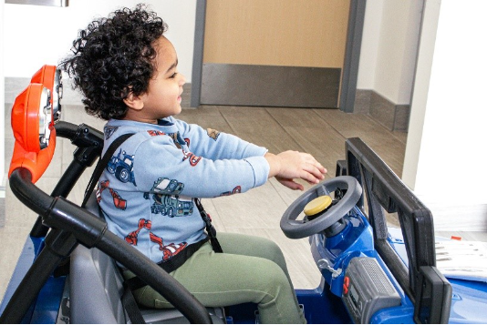
APPENDIX B - Picture of an existing solution from “Autodesk” and their joystick-controlled car.
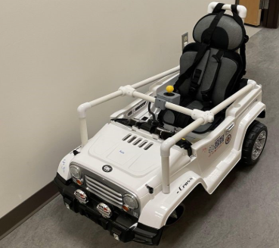
APPENDIX C – Block Diagram of the car’s circuit.
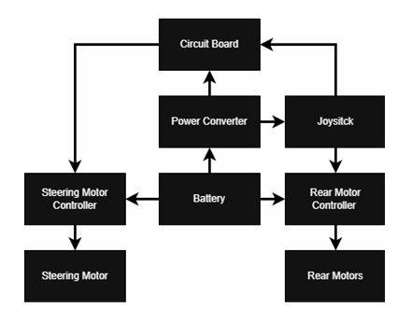
APPENDIX D – Internal switching logic of the arcade joystick.
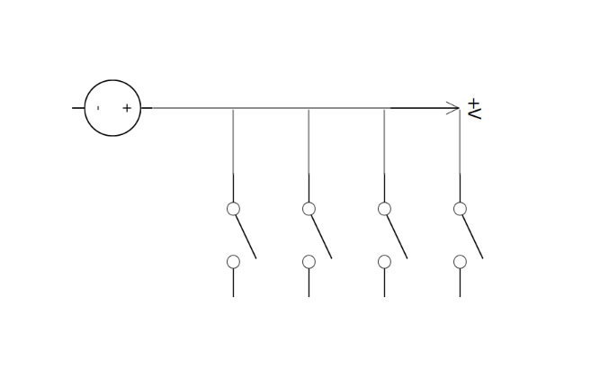
APPENDIX E – SolidWorks drawing of the joystick mount.
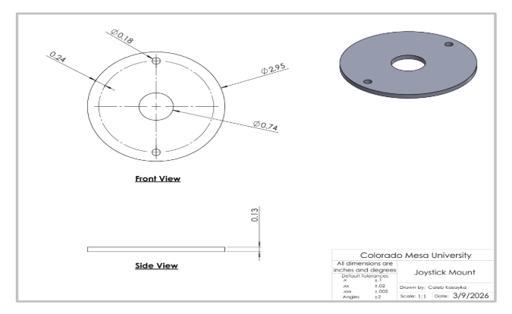

APPENDIX F – Function diagram of an H-Bridge Controller.
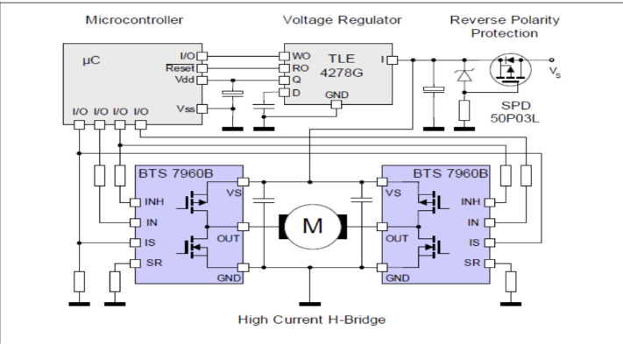
APPENDIX G – Diagram of a 555 timer and the respective pins.
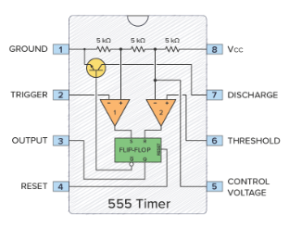
APPENDIX H – The circuit diagram of a pulse shaping module.
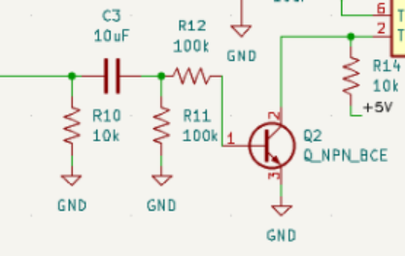

APPENDIX I – Image of the printed circuit board including 555 timers & the pulse shaping module.
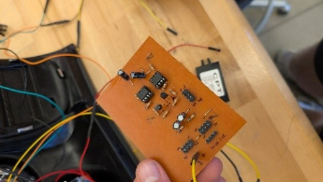
APPENDIX J – Table of bill of materials & cost estimate for the project.
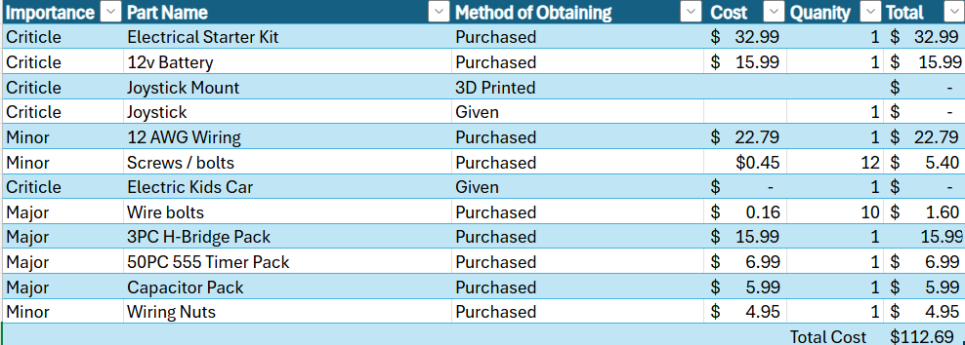APPENDIX K – Gantt chart of task deadlines.
